|  |  |  |  |  |  |  |  |  |  |  |  |  |  |  |  |  |  |  |
| --- | --- | --- | --- | --- | --- | --- | --- | --- | --- | --- | --- | --- | --- | --- | --- | --- | --- | --- |
| **INTERSTATE CONTAINER CORPORATION** | | ***Date:* 11/11/2016** | ***Spec #:*** | | | | | | | | | | ***Design #:*** | | **161320-02** |  |  |  |
|  |  |
| ***Customer:* DeMet's Candy** |  |  |  |  |  |  |  |  |  |  |  |  |  |  |  |  |  |  |
|  |  |  |  |  |  |  |  |  |  |  |  |  | ***Cut*** | **169 in.** | |  |  |
|  |  |  |  |  |  |  |  |  |  |  |  |  |  |  |
| ***Description:* Shipper - Shelf Ready TURTLES 17.5 oz Club Bag** | |  |  |  |  |  |  |  |  |  |  |  |  |  |  |
|  |  |  |  |  |  |  |  |  |  |  |  | ***Crease*** | **100 in.** | |  |  |
|  |  |  |  |  |  |  |  |  |  |  |  |  |  |
| ***Style:* RSC** | ***Revision Info:* [0] 11/10/2016:** |  |  |  |  |  |  |  |  |  |  |  |  |  |  |
|  |  |  |  |  |  |  |  |  |  |  |  |  |  |  |  |  |
|  |  |  |  |  |  |  |  |  |  |  |  |  |  |  |  |  |
| ***I.D. :* 22+3/8 x 6+7/8 x 10+1/4** | ***Blank size:* 13+7/8 x 60+1/2** |  |  |  |  |  |  |  |  |  |  |  |  |  |  |  |  |  |
|  |  |  |  |  |  |  |  |  |  |  |  |  |  |  |  |  |
| ***Board:* 32 C K** | ***Combination:* 35HP - 23M - 35HP** | ***Designer:* Alan Groff** |  |  |  |  |  |  |  |  |  |  |  |  |  |  |  |  |
|  |  |  |  |  |  |  |  |  |  |  |  |  |  |  |  |

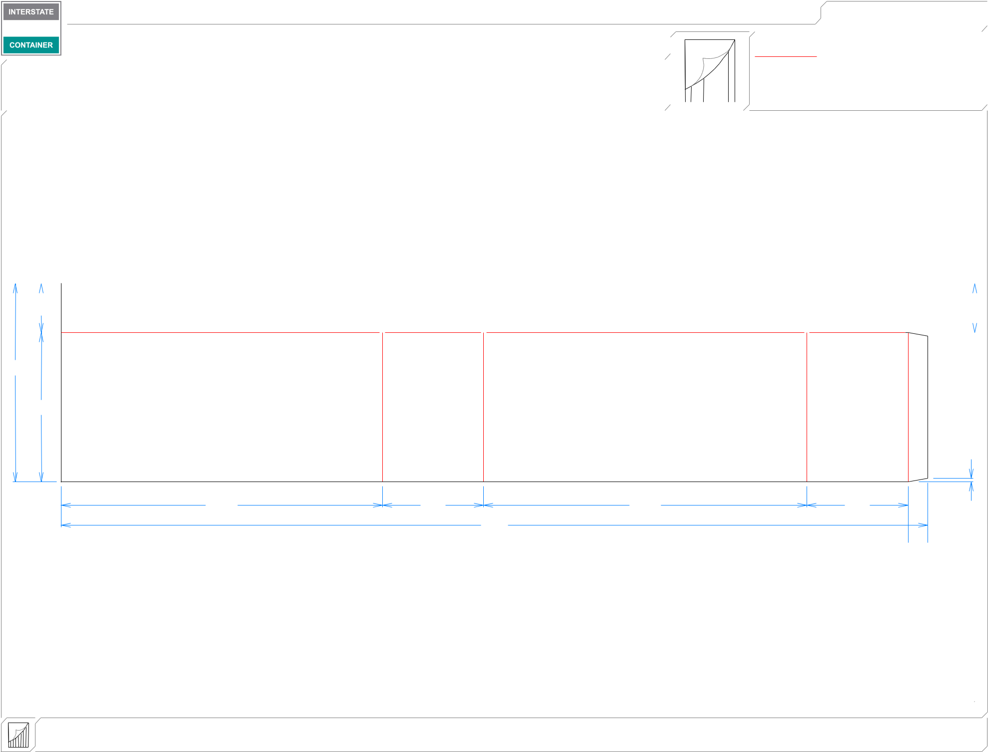

|  |  |  |  |  |  |  |  |  |  |  |  |  |  |
| --- | --- | --- | --- | --- | --- | --- | --- | --- | --- | --- | --- | --- | --- |
|  |  |  |  |  |  |  |  |  |  |  |  |  |  |
| 37*/*16 | |  |  |  |  |  |  |  |  | 37*/*16 | | | |
|  |  |  |  |  |  |  |  |  |  |  |  |  |  |

137*/*8

107*/*16

1*/*4

|  |  |  |  |
| --- | --- | --- | --- |
| 227*/*16 | 71*/*16 | 229*/*16 | 71*/*16 |
|  |  | 601*/*2 |  |

 13*/*8 

|  |  |  |  |  |
| --- | --- | --- | --- | --- |
| **inside view** | ***notes:* [Left hand 1/8"gap]** | |  |  |
| **Vertical Corrugation** | ***Qty/unit:*** | ***Area - waste:* 5.76 sq. ft** | ***Waste on blank:* 1.1%** | ***Piece weight - waste:* 0.6 lbs./274.1 g** |